1. **Basics**
   * 1. Declare a string variable called favouriteSubject.
     2. Assign to it the value “Computer Science”.
     3. Use Console.WriteLine to output the value of the variable to the Console.
     4. Declare two integer variables called number_1 and number_2.
     5. Use int.Parse(Console.ReadLine()) to assign two values entered by the user to the variables.
     6. Use Console.WriteLine to output the sum of the two variables to the Console.
2. **Football points calculator**

Write a program to calculate the number of points gained by a football team, given the number of wins, draws and lost games. 

Start by asking the name of the team

Then ask for the number of wins, then the number of draws.

Calculate the total number of points and display this total.

Assume:

* Win – 3 points;
* Draw – 1 point;
* Lose – 0 points

1. **Times Tables**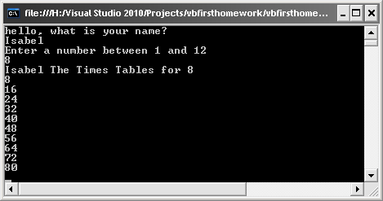
   1. Write a program that asks the user their name, and then asks them for a number between 1 and 12. Then display the times tables for the number given. The result should look like:
   2. Space the multiplication table out so that it is all lined up. Like this:  
        
        
        
        
        
      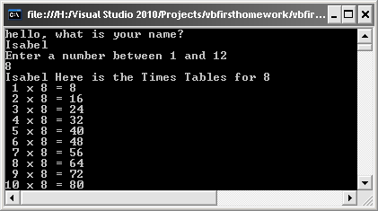
2. **Area of a Circle**
3. User enters the radius of a circle and the program displays the area.
4. Also calculate the area and volume of a cylinder

* User enters radius and height of the cylinder
* Area:
* Volume:

HINT: Use Math.PI for

1. **Binary to Decimal Converter**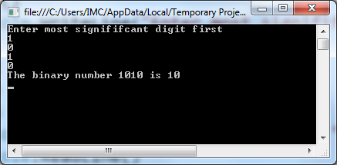

The user enters a 4 digit binary number one digit at a time. The program displays the decimal number. You will need to decide if the user enters in MSB or LSB first.

1. **VAT calculator**

User enters the price of an item and the program displays the VAT and the total price with VAT.

A constant is like a variable but its value doesn’t change. Make VAT a constant. To declare a constant:

const int VAT = 20;

1. **EXTENSION**

Make program 5 work for any length binary digit entered by the user.